AGAPE CHILDREN’S MUSEUM
AND
HARTE NEIGHBORHOOD LIBRARY
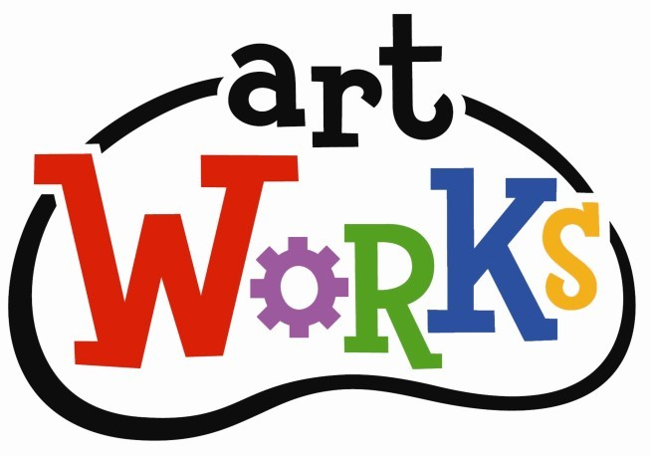
Explore the Language of art with hands on Activities! Ages 4-12
Saturday’s @ 1:30 PM – Jan 21, 28 - Feb., 11, 18, 25, - Mar., 4, 11, 18,
- Apr., 1,8, 15, 22, 29, - May., 6, 13, 20, 2023
Bret Harte Neighborhood Library
1595 W. Willow St. Long Beach, 90810
562 – 570-1044

