AGAPE CHILDREN’S MUSEUM

CONNECTING THE LOVE OF LEARNING THROUGH Art, Literacy, health and PLAY

MUSEUM MEDIA KIT

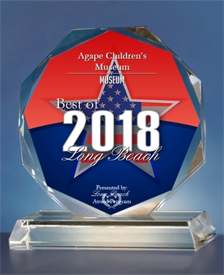
THE BEST OF LONG BEACH 2018
Agape Children’s Museum
At a Glance

Mission
▪ To provide a hands on learning environment that promotes the overall health and well-being of children and their families

Vision
▪ To create a world class children's museum serving Long Beach and the Southbay gateway cities.

What?
▪ Museum Without Walls
Traveling “museum” offering hands-on learning activities with varied formats at different venues

▪ The Launch Zone (First Operating Site)
A dynamic, interactive, and fun exploration center where the region's families and school groups can visit any day of the year for hands-on learning

▪ Full-Scale Museum
A world-class, full scale and accessible children's museum with hands-on exhibits and programs focusing on education, literacy, health, and the arts.

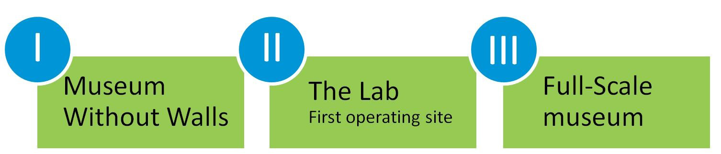

Where and When?
▪ The Launch Zone Art Gallery showcasing Children’s Art, Literacy and health masterpieces will be located in Long Beach, CA, opening in late Winter of 2024.
▪ The full-scale museum for the Arts, Literacy and Health dedicated to Children and families will be located in a potential development to be named in Long Beach, CA opening in the Summer of 2026.

AGAPE CHILDREN’S MUSEUM
Voted Best in Long Beach 2018
CONNECTING THE LOVE OF LEARNING THROUGH ART, HEALTH, LITERACY, AND PLAY
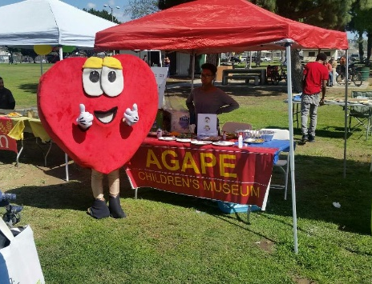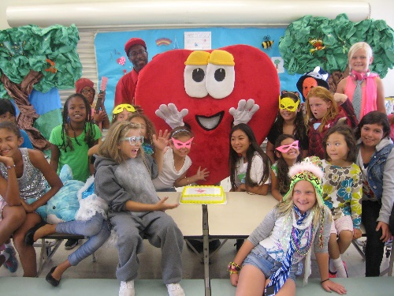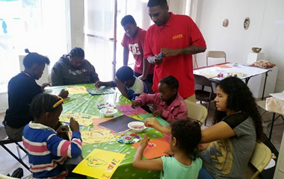
PROGRAMS AND OUTREACHES
Family Health Festival
Art Is Education Festival
Summer Hansen’s Children’s Day Celebration
Faith, Family and Literacy Fair
Thanksgiving Harvest Festival
Holiday Autism Toy Drive
Autism Family Fun Day
Kid’s Dental Health Day Celebration
The Red Party Fundraising Gala
The Color of the Season Art Experience
The Pop-Up Art Experience
After-School Art Experience
Summer Mini-Art Camps
Agapechildrensmuseum.org
MUSEUM LOGOS

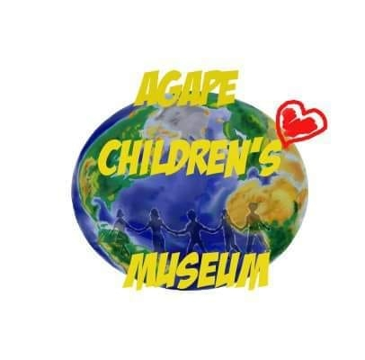

Connecting the Love of Learning though Art, Literacy, Health and Play.

https://agapechildrensmuseum.org/

https://m.facebook.com/Agape-Childrens-Museum

https://twitter.com/AgapeKidsMuseum

https://www.instagram.com/agape_childrens_museum/

Mailing Address: 613 W. 37th Street Long Beach, 90806
562-400-7174
FEDERAL TAX # 27-3292471

